Your Outreach to the Poor
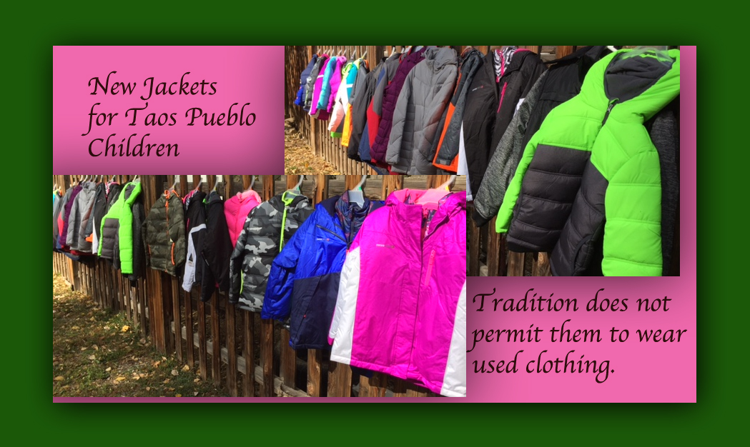
October 30, 2016

The Lord bless you, Heartdwellers, for your kindness to our mission.

I wanted to share the Scripture with you… And above all things have fervent charity among yourselves: for charity shall cover the multitude of sins. I Peter 4:8

It has totally warmed my heart that all of you have been so generous with us, so we've been able to buy jackets for the children on Taos Pueblo. Their tradition doesn’t allow them to wear used clothing, so we really helped them by supplying new jackets. Scarves, gloves and boots will come along, too, as we are able.

We also were able to help with food cards and utilities for families who were in danger of losing their water and electricity.

Thank you so much, Heartdwellers, thank you so very much.

As this holiday season approaches we are also working on helping others as much as possible. As the holiday season approaches, we're also planning on complete turkey dinners for the elderly and shut-ins that don't have anything. We've got plenty of things scheduled for the weeks ahead.

I really wanted you all to get a sense for our outreach here in Taos, so we are making an Outreach page on the Heartdwellers web site. We have just started collecting photographs and testimonials today, but it should be up within two days. And I'll remind you when it's fully up.

On this page of our website, we will have photographs and testimonials and details of who we’ve been helping here in Taos, as well as even a few receipts for food cards and a testimonial from Kit Carson Electric, who call us regularly when someone is about to have their electric cut off.

Among those who are struggling are grandmothers who are alone in raising their grandchildren, some of them with five or six children, and some of them are teen agers. And you know, teenagers eat a LOT OF food!

There are all kinds of programs that help with lunches and things on the Pueblo itself, but special needs come up where there is just no way the Pueblo can provide for everything.

We had one young couple with four children that needed help with an electrician, to get electricity run to their cabin that they're building. And they needed other building materials for their cabin. And she works very much in charity - she's constantly doing things for other people, and she has a little store, which is a free store, which people go in. The Giving Tree, and get whatever they need for free. And we cover the rent of her give-away store every month. You'll be able to see photographs of that on the Outreach page. So, she was really worthy of our help, and her husband is building their house. They both collect food and clothing for the poor. So, we helped her with the electricity and with the cost of having water piped in to their house. They live on the Pueblo, also.

But you can't imagine the poverty here, it really breaks your heart to hear about some of the situations, especially when a parent dies.

But because of the Lord's loving favor, we've been able to make a difference.

I’ve been busy getting photos together for the Outreach page, so please be patient with me about brining forth a message.

Last night the Lord asked me to write. And I said, Lord, what do You want me to write?

And He said, "Write about how good I’ve been to you."

Oh, my goodness - that could take a LONG while! But I began before I got sleepy, 'cause yesterday was a hectic day.

~Lord, you have taught us how to handle our foes, and delivered us from their hands.
~You have provided amply for our poor.
~You have brought peace to our borders and health to our bodies.
~You’ve given us new hope, and a fresh anointing and told us how vital our sufferings are to Your plan. And how grateful You are for them.
~You strengthen us with Your grace every day, and You teach us. And You're constantly protecting us.
~You are working behind the scenes to make sure the right man is voted into office…

Jesus, I could go on forever about Your goodness. And You’ve given us new songs, to boot.

Yes, Ezekiel and I are both working on music and I have to tell you, there are some very good songs ministering God’s Love and Our Love for Him coming soon. But for now, I am going into prayer to see what the Lord would like to say to you. And get a message together for tomorrow.

So, please forgive this short message.

We love you all and appreciate you so very, very much.

